**COMPUTER NETWORK 1**

**LAB1**

**NETWORK DEVICES**

**Student Name: Đinh Hoàng Anh**

**Student ID: 1952553**

1. **NIC**

* **NIC functions:**
* Is an intermediary between a computer and a data network, allowing the connection of a computer and a data network
* NIC allows both wired and wireless communications
* NIC allows communications between computers connected via LAN as well as communications over large-scale network through IP
* NIC is both a physical layer and a data link layer device.
* **MAC Address of my laptop:**
* Ethernet adapter Ethernet2: 50-46-5D-30-93-4C
* Wireless LAN adapter Local Area Connection\* 9: 1A-94-23-C8-4C-F1
* Wireless LAN adapter Local Area Connection\* 10: 2A-94-23-C8-4C-F1
* Wireless LAN adapter Wi-fi: 68-94-23-C8-4C-F1
* Ethernet adapter Bluetooth Network Connection: 68-94-23-C8-4C-F2
* **Cable to connect NIC to a network:**
* Type: Ethernet Cable
* Standard: RJ45

1. **Hubs**

* **Roles of hub in a network:**
* Connect multiple devices in a network.
* Generally used to connect computers in a LAN.
* **Main characteristics:**
* A hub operates in the physical layer of the OSI model.
* A hub cannot filter data. It is a non-intelligent network device that sends message to all ports.
* It primarily broadcasts messages. So, the collision domain of all nodes connected through the hub stays one.
* Transmission mode is half duplex.
* Collisions may occurs during setup of transmission when more than one computers place data simultaneously in the corresponding ports.
* Since they lack intelligence to compute best path for transmission of data packets, inefficiencies and wastage occur.
* They are passive devices, they don’t have any software associated with it.
* They generally have fewer ports of 4/12.
* **Weakness:**
* The function of the collision domain and again transfer of packet does not affect actually it increases more chances of collision in between domains.
* Hubs cannot communicate fully duplex mode, it can only operate in half-duplex mode. Half-duplex mode, in essence, means data are often transmitted just one occasion at a given time. Therefore, the hub must constantly switch its modes.
* Hubs cannot support networks that are large like a token ring. This is often because hubs must share data among all the devices within the network.
* As the attachment was received in the packet so it cannot reduce traffic. Hence, hubs make a high level of network traffic.
* Hubs cannot provide dedicated bandwidth for every device, it is to share them. When sending large pieces of information all the bandwidths are going to be occupied by the two computers leaving other computers with slow network.
* Hub ports:
* It has multiple input/output ports, in which a signal introduced at the input of any port appears at the output of every port except the original incoming
* Standard: RJ45, BNC, Attachment Unit Interface (AUI) (allows 10BASE2 or 10BASE5 network segments)

1. **Switches**

* **Roles:**
* Connect multiple hosts: Normally, a switch provides a large number of ports for cable connections, allowing for star topology routing. It is usually used to connect multiple PCs to the network.
* Forwards a message to a specific host: Like a bridge, a switch uses the same forwarding or filtering logic on each port. When any host on the network or a switch sends a message to another host on the same network or the same switch, the switch receives and decodes the frames to read the physical (MAC) address portion of the message.
* Manage traffic: A switch in networking can manage traffic either coming into or exiting the network and can connect devices like computers and access points with ease.
* Keep electrical signal undistorted: When a switch forwards a frame, it regenerates an undistorted square electrical signal.
* Increase LAN bandwidth: A switch divides a LAN into multiple collision domains with independent broadband, thus greatly increasing the bandwidth of the LAN
* **Main Characteristics:**
* A switch operates in the layer 2, i.e. data link layer of the OSI model.
* It is an intelligent network device that can be conceived as a multiport network bridge.
* It uses MAC addresses (addresses of medium access control sublayer) to send data packets to selected destination ports.
* It uses packet switching technique to receive and forward data packets from the source to the destination device.
* It is supports unicast (one-to-one), multicast (one-to-many) and broadcast (one-to-all) communications.
* Transmission mode is full duplex, i.e. communication in the channel occurs in both the directions at the same time. Due to this, collisions do not occur.
* Switches are active devices, equipped with network software and network management capabilities.
* Switches can perform some error checking before forwarding data to the destined port.
* The number of ports is higher – 24/48.
* 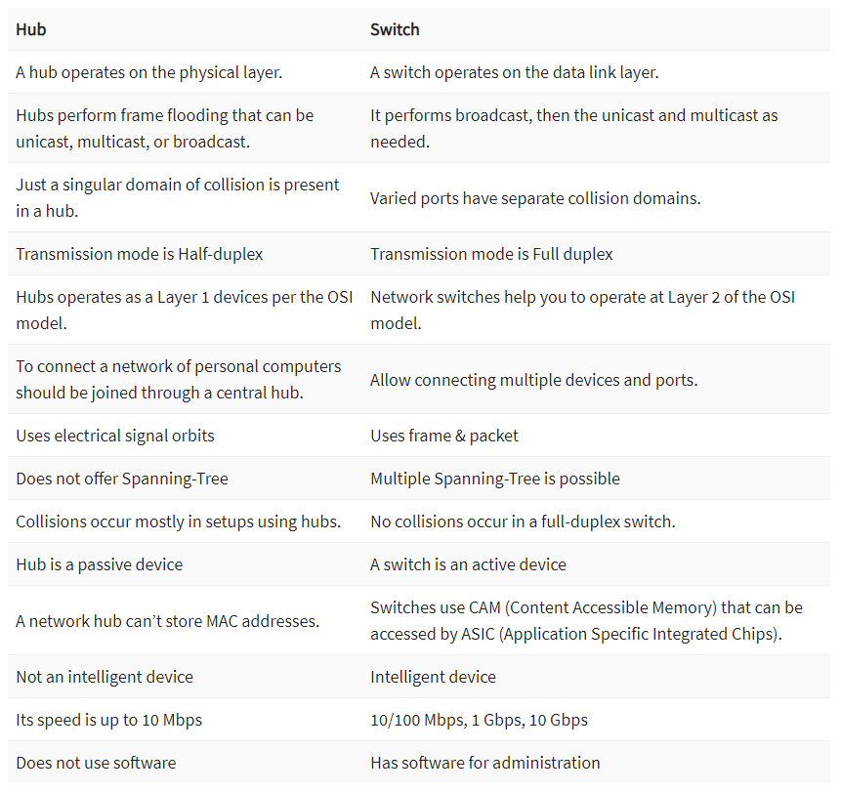**Differences between hubs and switches:**
* **Weakness:**
* The number of ports is higher – 24/48.
* They are more costly in contrast with network spans.
* Network availability issues are hard to be followed through the organization switch.
* Broadcast traffic might be problematic.
* If switches are in the indiscriminate mode, they are defenseless against security assaults for example caricaturing IP address or catching Ethernet outlines.
* Proper planning and arrangement are required to deal with multicast parcels.
* The switch’s mechanical component can wear out with time.
* Must have physical contact with the object to be actuated.
* **Switch ports:**
* RJ45 port on 100/1000BASE switch can be used in data centers for server switching, LANs, uplinks from desktop switches or directly to the desktop for broadband application. A standard Ethernet cable ([Cat5/5e/6/6a cable](https://www.fs.com/c/cat5e-cat6-cat7-cat8-904" \t "_blank)) is often used when connecting two RJ45 ports on Gigabit switches.
* SFP Port (mini-GBIC port) is a small-sized hot-swappable interface. Typical speeds were 1 Gbit/s for Ethernet SFPs and up to 4 Gbit/s for Fiber Channel SFP modules. SFP port enables a gigabit switch to achieve fiber uplinks over longer distances or short-range copper uplinks by inserting corresponding [SFP modules](https://www.fs.com/c/sfp-transceivers-57) (fiber SFP or copper SFP).SFP+,
* SFP+ port (small form-factor pluggable plus) is an enhanced version of SFP port, supporting higher speeds up to 10Gbps. In terms of SFP vs SFP+ compatibility, SFP+ ports often accept SFP optics but at a reduced speed of 1Gbps. However, you cannot plug an SFP+ transceiver into an SFP port because SFP+ does not support speeds less than 1Gbps.
* SFP28 port is an enhanced version of SFP+ port. SFP28 has the same common form factor as the SFP+, but supports 25Gb/s over a single lane. SFP28 provides a new way for networking upgrade: 10G-25G-100G, which is an energy-efficient solution to meet the growing demands of next-generation data center networks.
* QSFP+ port is an evolution of QSFP (quad small form-factor pluggable) port designed to 4x10G lanes to support 40G Ethernet. That’s to say, it has four-channel 10 Gbit/s SFP+ interfaces which can transfer rates up to 40Gbps.

1. **Routers**

* **Roles:**
* A router is a networking device that forwards data packets between computer networks. Routers perform the traffic directing functions on the Internet. Routers make the Internet work by forwarding data using a unified addressing system. They can send information to anywhere in the world as long as that location has an IP address.
* **Main Characteristics:**
* Routers are multi-port devices with high – speed backbones
* Routers also support filtering and encapsulation like bridges
* Like bridges routers are also self-learning, as they can communicate their existence. to other devices and can learn of the existence of new routers, nodes and LAN segments
* As explained earlier, they route traffic by considering the network as a whole. It shows that they use a high level of intelligence to accomplish this task. This characteristic makes them superior than hubs and bridges because they simply view the network on a link-by-link basis
* The packet handled by router may include destination address, packet priority level, least-cost route, minimum route delay, minimum route distance, and route congestion level
* Routers constantly monitor the condition of the network, as a whole to dynamically adapt to changes in the condition of the network
* They typically provide some level of redundancy so that they are less susceptible to catastrophic failure.
* **Differences between routers and switches:**

|  |  |
| --- | --- |
| **Switch** | **Router** |
| It connects multiple networked devices in the network. | It connects multiple switches & their corresponding networks. |
| It works on the data link layer of the OSI model. | It works on the network layer of the OSI model. |
| It is used within a LAN. | It can be used in LAN or MAN. |
| A switch cannot perform NAT or Network Address Translation. | A router can perform Network Address Translation. |
| The switch takes more time while making complicated routing decisions. | A router can take a routing decision much faster than a switch. |
| It provides only port security. | It provides security measures to protect the network from security threats. |
| It comes in the category of semi-Intelligent devices. | It is known as an Intelligent network device. |
| It works in either half or full-duplex transmission mode. | It works in the full-duplex transmission mode. However, we can change it manually to work on half-duplex mode. |
| It sends information from one device to another in the form of Frames (for L2 switch) and the form of packets (for L3 switch). | It sends information from one network to another network in the form of data packets. |
| Switches can only work with the wired network. | Routers can work with both wired & wireless networks. |
| Switches are available with different ports, such as 8, 16, 24, 48, and 64. | A router contains two ports by default, such as Fast Ethernet Port. But we can also add the serial ports explicitly. |
| It uses the CAM (Content Addressable Memory) table for the source and destination MAC address. | It uses the routing table to get the best route for the destination IP. |

* **Routers ports:**
* Aux port: This auxiliary port is used to connect a modem to the router, which can then be used to remotely modify the configuration on the router.
* Attachment Unit Interface (AUI) port: Before the WIC became a standard for providing expansion through an add-on port, the AUI allowed transceivers to be used, providing you with the ability to add various types of network connections, such as fiber or copper Ethernet connections. A transceiver is a small electronic device that converts electrical signals from the AUI specification on one side of the transceiver to that of the connection type on the other side of the transceiver. An AUI port is shown in the following figure.
* Serial: Connects a modem or other serial device to allow a WAN network interface to be used on the router.
* Ethernet/Fast Ethernet/Gigabit Ethernet: Standard network interfaces used to connect different network segments.
* Console: Serial configuration port for command-line access to router management and configuration. Refer to Figure 3-1 to see the console port.
* WAN Interface Card (WIC) port: Because a wide variety of WAN connectivity options are available (for example, T1, ISDN, ADSL), you can use this port to add different interfaces to a standard router.
* Hardware WAN Interface Card (HWIC) port: With the integration of services into routers, the WIC interface became too limiting. The HWIC interface was created to support a wider variety of hardware expansion options, such as switches and service cards. This port is backward compatible with most older WIC hardware.

1. **Access point**

* **Roles:**
* An [access point](https://www.ligowave.com/products/nft-series) is a wireless network device that acts as a portal for devices to connect to a local area network. Access points are used for extending the wireless coverage of an existing network and for increasing the number of users that can connect to it
* **Main characteristics:**
* Access points are the basic elements of a wireless network – They scan for the wireless devices in its range and all the neighbouring Wi-Fi systems connect to the Access Point to communicate with the network.
* Access points offer a standard for connectivity – a, b/g, b/g/n which are all ratified by IEEE so that the Wi-Fi systems from various vendors can connect to the network.
* Access points connect to PC’s, laptops, PDA’s, mobiles, Wi-Fi phones, Wi-Fi Cameras, Wi-Fi display management systems and a host of other devices that work on the Wi-Fi standard.
* Access points can also scan the network for wireless threats and attacks.
* **Interfaces:**
* Command-line interface (CLI), the browser-based management system, or Simple Network Management Protocol (SNMP).
* **Differences between Access Point and Routers:**
* The router acts as a hub that sets up a local area network and manages all of the devices and communication in it. An access point, on the other hand, is a sub-device within the local area network that provides another location for devices to connect from and enables more devices to be on the network.  
  Wireless routers can function as access points, but not all access points can work as routers. While routers manage local area networks, communicate with outside network systems, acquire, distribute, and dispatch data in multiple directions, establish a point of connectivity, and ensure security, access points typically only provide access to the router’s established network.
* **Differences between Access Point and Switches:**
* A switch connects various Ethernet devices via individual cables, acting as the center of the star-shaped network.
* An access point connects various Wi-Fi devices to the wired network (the access point itself is one of the Ethernet devices connected to the switch using a cable).
* **Differences between Access Point and Switches:**
  + - A hub can’t identify the source or destination of the information it receives, so it sends the information to all of the computers connected to it, including the one that sent it. A hub can send or receive information, but it can’t do both at the same time.
    - Access points provide wireless access to a wired Ethernet network. An access point plugs into a hub, switch, or wired router and sends out wireless signals. This enables computers and devices to connect to a wired network wirelessly.

1. **Modem**

* Dial-up will also allow you to view most websites, generally content-heavy ones. But sites loaded with graphics, animations and other tricks will take a while to load. For real-time viewing and videos, dial-ups can’t perform as well. The connection will also hog the phone line so making or receiving phone calls when internet access is on can only be done using a separate line.
* DSL stands for Digital Subscriber Line. It is a type of broadband connection and considerably much faster than dial-up. The two most common types are ADSL (asymmetrical) and SDSL (symmetrical). A DSL connection will not tie up a phone line. It’s always available so there is no need to dial an ISP. DSL speeds can go from several hundred kbps to around 8 Mbps. This much speed allows high volume data use, loads websites quickly and is quite efficient to use with live chats, viewing videos in real time and playing online games.
* Cable internet connection is faster than a dial-up but sometimes slower than DSL. Internet connection is obtained using a cable modem. This connection will be shared on lines used for cable TV. To transmit data, space reserved for TV channels are used, some to handle upstream transmissions and others for downstream transmissions.

1. **Connecting network devices:**
2. Computer and hub: Straight-through
3. Computer and switch: Straight-through
4. Computer and router: Crossover
5. Hub and hub: Crossover
6. Hub and switch: Crossover
7. Hub and router: Straight-through
8. Switch and switch: Crossover
9. Switch and router: Straight-through
10. Router and router: Crossover